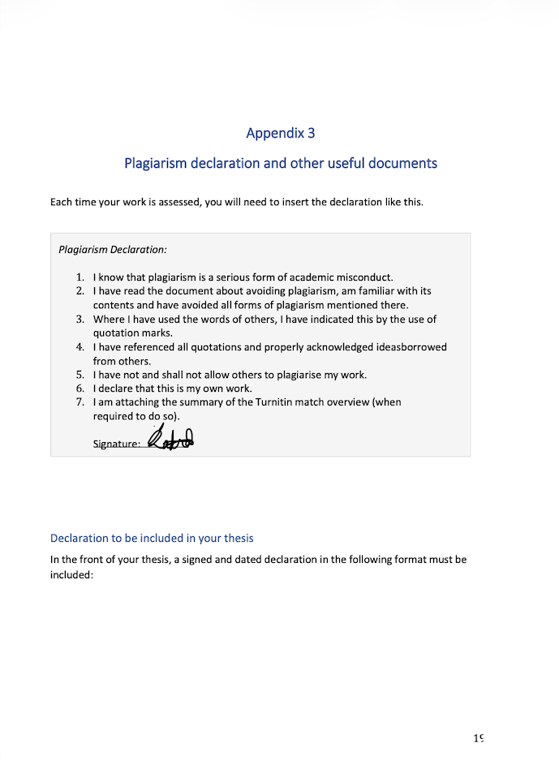

I referenced the Amazon links within my HTML files where I received each product information from. I received a product description of the Iphone 13 from Google AI Overview which I also referenced in my mobile.html file. I came in with semi-intermediate knowledge in HTML/CSS but I used AI to get quick references and understanding/refreshers of tags such as what tag do I use for breaking up sentences, what tag adds a shadow to text, and what tag can position an element in a certain way (whether center, right, etc).

